WeVideo
Logging in
- If you have an email address, you may, with parental permission, use it to create an account for WeVideo. This will make is so that you will only see your own images that you upload to WeVideo.

- You can use our momsmediacenter@gmail.com account to sign in to WeVideo. The password is Mustangs ( capital M). When you sign in to WeVideo using this account, you will see the images that others have uploaded to WeVideo. Please do not delete others’ images!
Building a Video
After installing the app to your Chrome browser (make sure you are logged in properly to Chrome), open the app.
Click the Log In button if you are using the momsmediacenter@gmail.com login, or click Sign Up, if you have permission to use your personal email accounts.
Click Create New Video
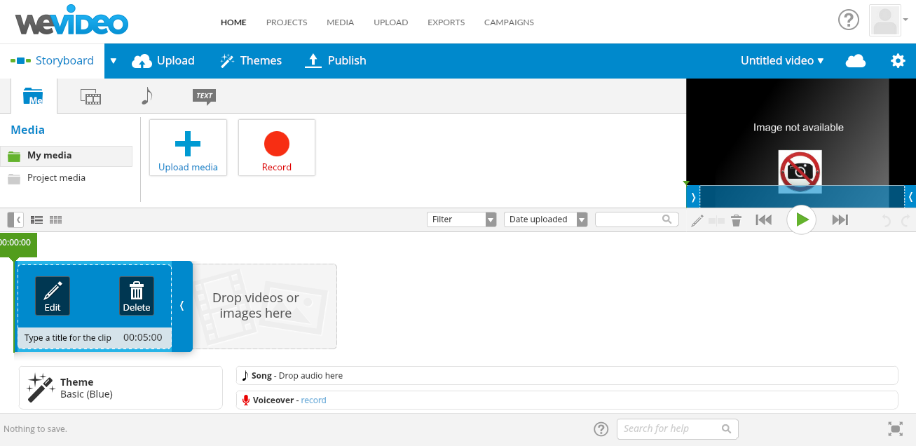
1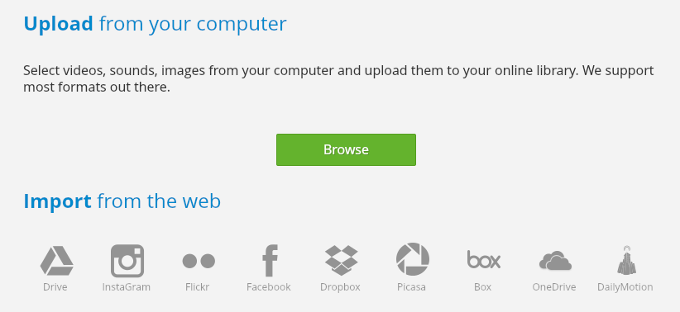
1
Choose Drive

Choose the file you created for this project. The file will open, and then you can choose the images and click Upload.
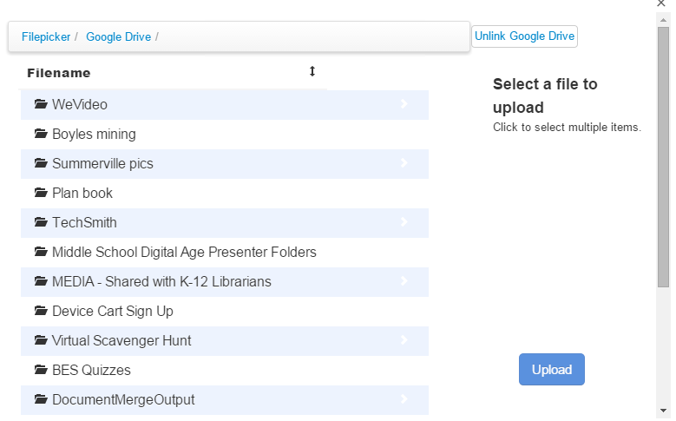
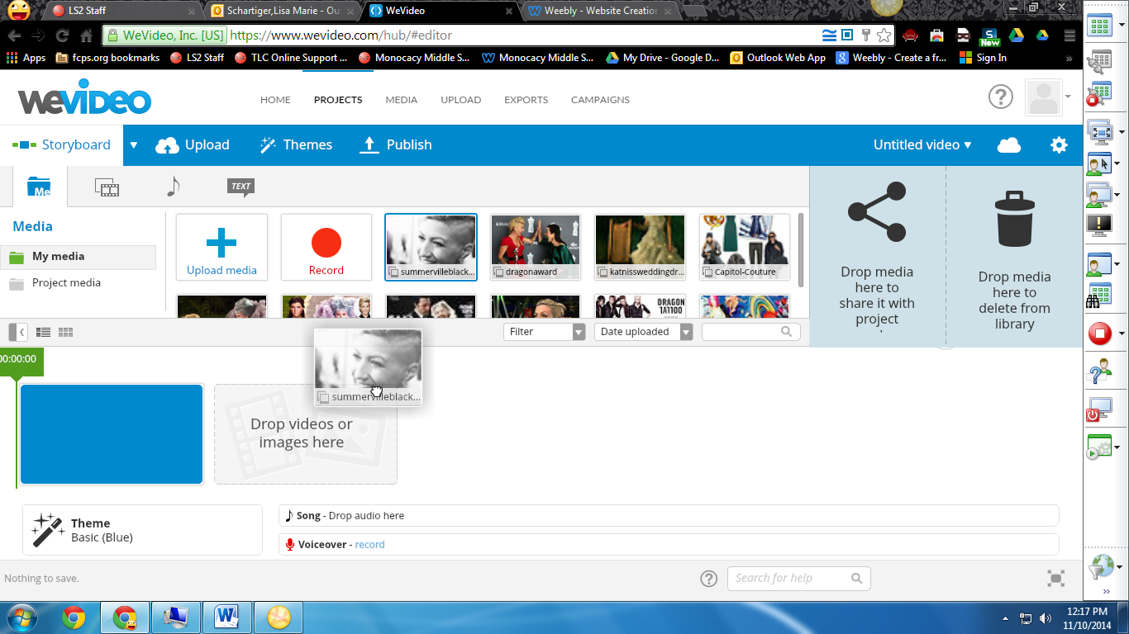
Click Record in the Voiceover timeline when you are ready to record your script. Follow the prompts on the screen.
Drag and drop individual images into your time line in the order that you want them to appear. Use your voice over script as a guideline for the order in which images should appear.

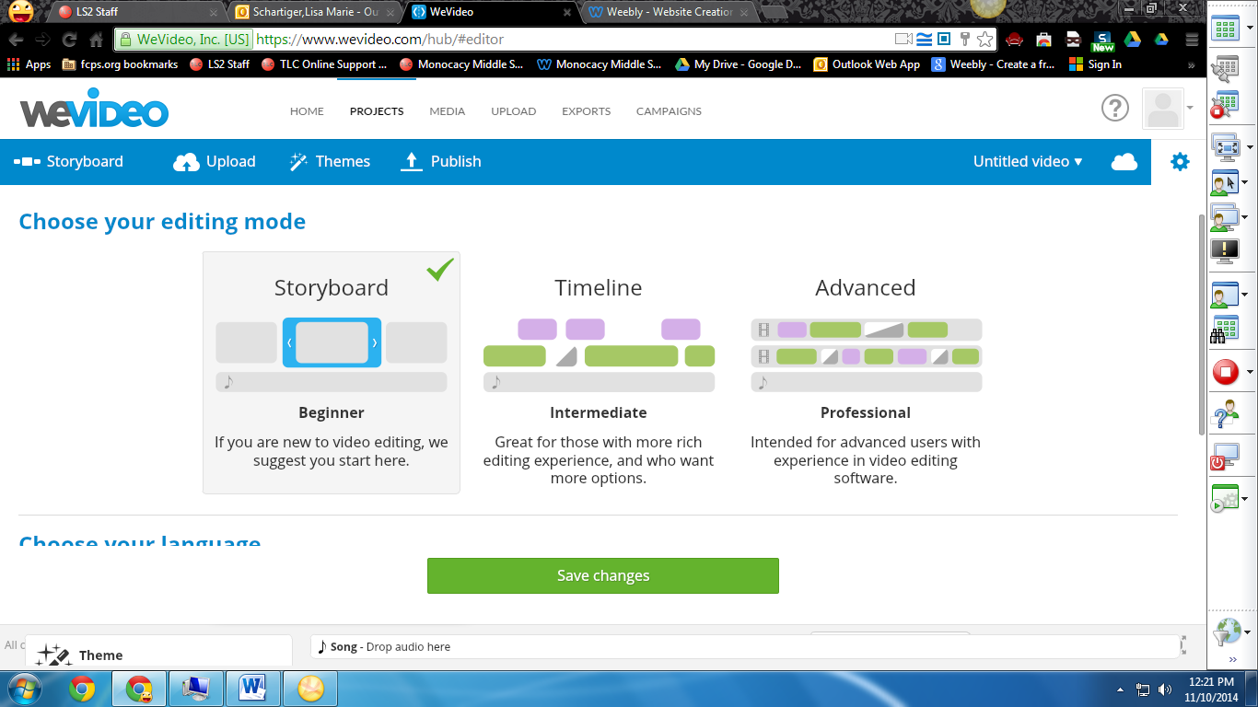
Click the setting wheel to go to the timeline mode. This will allow you to make more fine adjustments to your video.

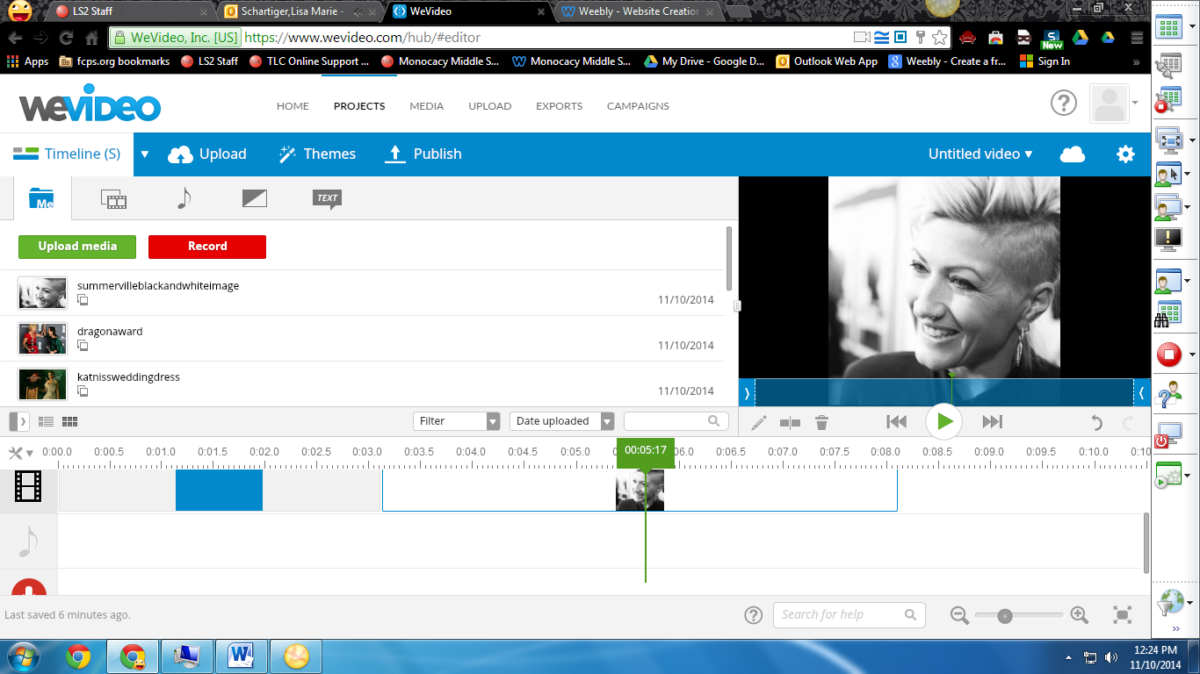
Make adjustments to the lengths of you media clips

Preview your changes along the way

